- Download and Install Visual Studio 2017 (Community Edition)
- Open QATesting.sln file from project home directory
- Please add following references to Solution if it wouldn't added automatically.
  - Nunit, SpecRun.runner , MSTest.TestAdapter , MSTest.TestFramework, Newtonsoft.Json , Otp.NET , Selenium.WebDriver , Selenium.WebDriver.ChromeDriver , SpecRun.SpecFlow
- 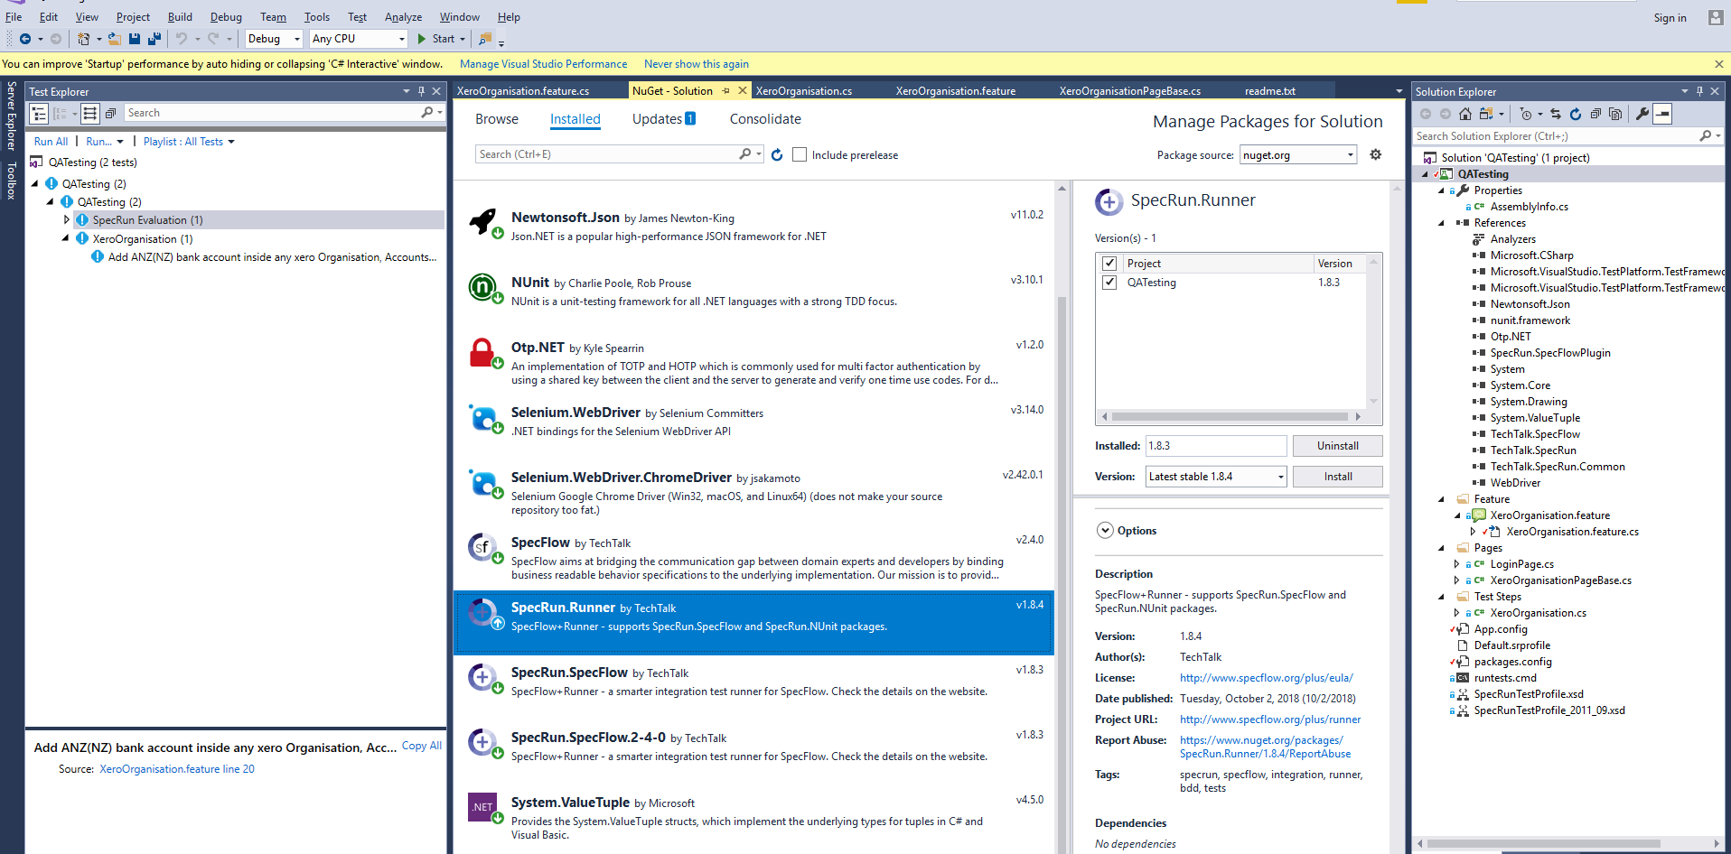
- Build solution from Build menu.

- Run test case "Add ANZ(NZ) bank account inside any xero Organisation" from XeroOrganisation
